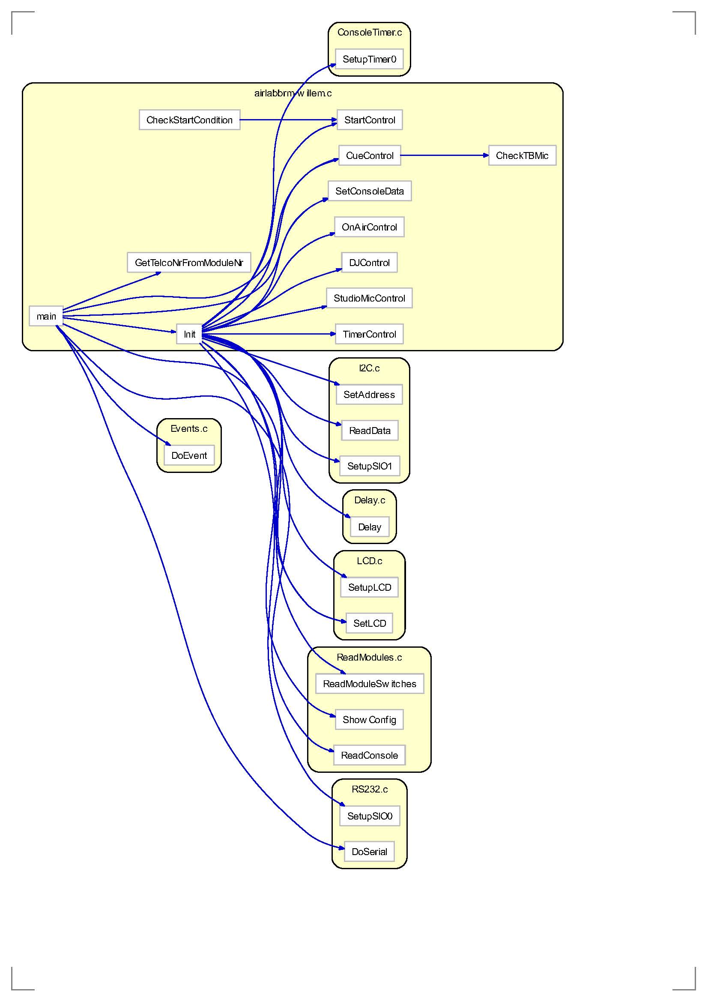

sbit LCD_D4 = 0xC0;

sbit LCD_D5 = 0xC1;

sbit LCD_D6 = 0xC2;

sbit LCD_D7 = 0xC3;

sbit LCD_RW = 0xC4;

sbit LCD_RS = 0xC5;

sbit LCD_E = 0xC6;

sbit STRB1 = 0xC7;

sbit P10 = 0x90; //read master AS0

sbit P11 = 0x91; // AS1

sbit P12 = 0x92; // AS2

sbit P13 = 0x93; // AS3

sbit P14 = 0x94; // AS4

sbit P15 = 0x95; // STRB2

sbit P16 = 0x96; // SCL

sbit P17 = 0x97; // SDA

sbit CLK1 = 0xB4;

sbit DATA1 = 0xB2;

sbit CLK2 = 0xB5;

sbit DATA2 = 0xB3;

sbit STRB2 = 0x95;

sbit TXD = 0xB1;

sbit RXD = 0xB0;

#define ESCAPE 0x80

#define ENTER 0x81

#define RIGHT 0x82

#define DOWN 0x83

#define UP 0x84

#define LEFT 0x85

#define CUERESET 0x86

#define SW_CC 0x87